Classification of Retinal Diseases based on Optical Coherence Tomography Images using Transfer Learning
Shaivi Rutvij Panchal, Reva Sameer Laghate, Omkar S Powar*
Department of Biomedical Engineering, Manipal Institute of Technology, Manipal Academy of Higher Education, Manipal, Karnataka, India - 576104
*omkar.powar@manipal.edu

Abstract
Choroidal Neovascularization (CNV), Diabetic Macular Edema (DME), and Age-related Macular Degeneration (AMD) are some of the prime causes behind central vision loss globally. Optical Coherence Tomography is an imaging modality which non-invasively provides cross-sectional images of high-resolution, especially that of the eye. These images are beneficial in disease categorization. Based on these scans, InceptionV3 and MobileNetV2 architectures were employed to predict retinal diseases into CNV, DME, DRUSEN, and NORMAL. To address class imbalance, methods such as class weights and data augmentation were applied. The pre-trained deep learning models were fine-tuned with custom layers. Experimental results demonstrated test accuracy of 96.83% for InceptionV3 and 95.05% for MobileNetV2. Both these accuracies show their ability in differentiating between retinal conditions. CNV and Normal classes portrayed strong classification while classification of drusen suffered challenges. These findings confront class imbalance challenges and exhibit the impact of deep learning techniques to support ophthalmologists in the premature detection of retinal conditions to improve treatment outcomes.
Keywords: Retinal Disease Classification, Optical Coherence Tomography, Drusen, Diabetic Macular Edema (DME), Choroidal Neovascularization (CNV), InceptionV3, MobileNetV2, Class weights.

I. Introduction
In individuals over 65, Age-related Macular Degeneration is a prominent cause of vision loss. It accounts for about 8.7% of all vision-loss cases, globally. It affects the central vision due to its effects on the macula. This leads to distorted or blurred vision. AMD can be generalized into wet and dry forms. The 'wet AMD' is associated with choroidal neovascularization (CNV), which is excessive blood vessel growth from the choroid), as shown in Figure 1. The 'dry AMD' form is associated with yellow deposits that accumulate under the retina. These are called drusen [1–3]. Diabetic Macular Edema (DME) is another considerable contributor to vision loss, caused by the leaking of fluid into the retina due to hyperglycemia [4]. It is most observed in individuals with diabetic retinopathy. Optical Coherence Tomography (OCT) is a non-invasive imaging modality. It is employed to acquire cross-sectional images of retinal layers [5,6]. It outperforms other imaging modalities due to its speed, clarity and ability to highlight minute changes. Despite these advantages, accurate diagnosis using OCT remains a resource-intensive process. This creates challenges in regions with limited access to trained specialists, such as India, which has low doctor-to-patient ratio [7]. Thus, computer-aided diagnostic systems could help ease clinician’s workload. By applying deep learning, automated models can now extract disease-relevant features from OCT images to support medical decision-making [8˗10]. Machine learning models like SVMs and CNNs also show promising results in classifying such diseases [11]. However, CNNs require long training times and large annotated datasets [12]. By leveraging pre-trained models, transfer learning models address this limitation by improving accuracy and reducing overfitting, even with smaller datasets [13].
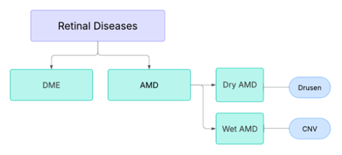Figure 1 Categorization of Retinal Diseases
InceptionV3 is a convolutional neural network (CNN) architecture, that although is computationally expensive, it delivers high accuracy and efficiency due to its optimized convolutions and grid size reduction [14]. MobileNetV2 is a lightweight CNN architecture that achieves efficient performance through depth wise separable convolutions and inverted residual blocks.
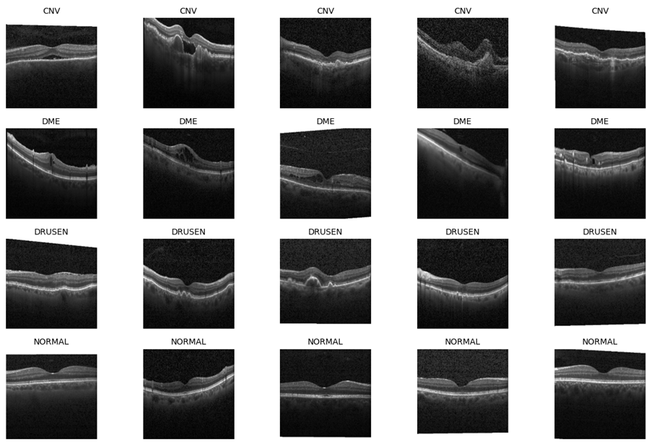
Several studies have applied machine learning models to sorting retinal diseases using OCT scans. Udayaraju et al. (2023) used SVM for DME detection on 112 scans, achieving 98.37% accuracy. Schwartz et al. (2022) applied 3D Inception V1 to 1,276 Drusen images, reporting 98.4% accuracy with 97.8% sensitivity and 99% specificity. Errabih et al. (2022) evaluated InceptionV3 and VGG16 on a large dataset of 84,483 images, with VGG16 yielding 93.12% accuracy and high sensitivity for CNV (100%), Drusen (92%), and DME (89%). Kumar et al. (2022) developed a deep CNN for OCT-based retinal disease detection with image enhancement and transfer learning. InceptionV3 attained 74.7% accuracy, whereas MobileNetV2 75.29%. Ben Yang et al. acquired a 98.96% on their improved version of MobileNet. Pranoto et al. (2021) developed a custom 5-layer CNN model to differentiate DME images from normal retinal OCT scans, achieving a peak classification accuracy of 96% over MobileNet’s 64% and VGG-16’s 93% accuracy. These findings demonstrate the efficacy of deep learning approaches for OCT classification, enhanced by synthetic data augmentation providing further gains [7].
Figure 2 Representation of Samples across the Retinal OCT Dataset Classes: CNV, DME, DRUSEN, and NORMAL

In the following sections, we explore the usage of deep learning techniques to accurately classify retinal diseases. While prior work has employed SMOTE to reduce the impact of class imbalance, we investigated an alternative approach using class-weighted loss functions which are better suited for large-scale image datasets to reduce bias and enhance sensitivity for underrepresented classes.

II. Methodology
- Dataset
The “Large Dataset of Labeled Optical Coherence Tomography (OCT) and Chest X-Ray Images” dataset by Kermany et al. (2018), is a comprehensive collection of medical images curated for research purposes (Figure 2) [3]. It comprises of thousands of validated OCT scans, each classified into four categories: CNV, DME, DRUSEN, and NORMAL. Each image is labeled with the corresponding disease type, patient ID, and an image index [14]. In this work, we use the Labeled Optical Coherence Tomography (OCT) dataset by Anirudh CV on Kaggle, which is a cleaned and restructured version of the original dataset published by Kermany et al. (2018).

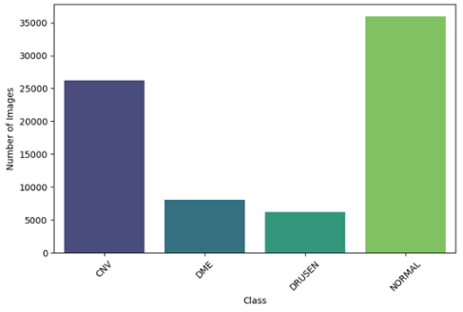Figure 3 Distribution of Samples across classes
The Kaggle version provides 109,309 total images across the four classes. Kermany et al. initially reported 1,000 test and 108,312 training images; however, later analysis (Takumasa et al., 2020) revealed differences in file counts between versions. The Kaggle dataset is appropriate for this study while remaining in line with the original data source and clinical intent because it is a curated and easier-to-access derivative that provides consistent data integrity and simpler reproducibility.
The dataset suffers from significant class imbalance, with a higher number of NORMAL images (35,973) compared to DRUSEN (6,206), as shown in Figure 3. This imbalance might lead the model to favour the majority class during training. To address this issue, we used class-weighting and data augmentation were employed. While SMOTE is used for imbalanced datasets, it is not ideal for deep learning because it can cause overfitting and limits the diversity of generated samples [15].
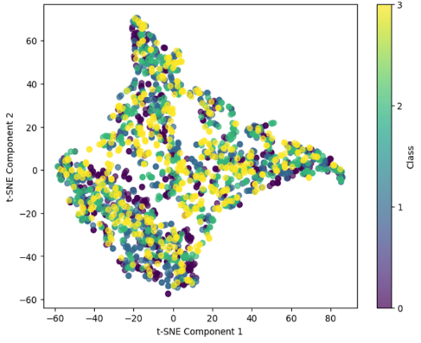
Figure 4 t-SNE Scatter Plot of the Dataset with Four Classes

Data Preparation and Pre-Processing
OCT Images were loaded in grayscale to reduce complexity to enhance structural details, ensuring consistent single channel input. A batch size of 32 was chosen in order to balance computational efficiency and class representation. During preprocessing, the images were resized to 224x224 pixels. This was done to fit the input size of the InceptionV3 and MobileNetV2 models. Pixel intensities were normalized to be in the [0,1] range to standardize input scaling. Data augmentation methods were applied including flipping, zooming, and changing brightness in order to add variability to the dataset. Class labels were one-hot encoded. Figure 4 a t-SNE scatter plot of the training set to visualize high dimensional feature representation. The plot indicates a significant amount of overlap, indicating there is still a high amount of variance even for the same class. The frequent overlaps of color indicates that there is class imbalance while more scattered points can indicate noise. The noticeable lack of clusters suggests that the extracted features do not create significant separation in a linear space.
- Model Architecture
The top layers of the base architectures, InceptionV3 and MobileNetV2, were removed to allow custom classification. First hundred layers of each were frozen to retain features. The deeper layers were kept trainable. GlobalAveragePooling2D reduced spatial dimensions and minimized overfitting. A dense layer and softmax activation function for output class probabilities were applied. Adam optimizer was used to compile these models. To improve model performance, callbacks such as ReduceLROnPlateau and EarlyStopping were employed.

- Evaluation Metrics
The model performances was judged on their accuracy, precision, recall, AUC, and the confusion matrix. Accuracy measured overall correctness, AUC assessed discriminative ability, and precision and recall indicated sensitivity to false results. The confusion matrix offered detailed class-level insights into misclassifications.
- Experimental Setup
Both sections of the experiment were conducted on a NVIDIA RTX 4080 Super GPU with 64 GB RAM, and an Intel Core i9 processor, using Python 3.9 and TensorFlow 2.10. InceptionV3 and MobileNetV2 employed ImageNet pre-trained weights, with early stopping configured at a patience of 10 epochs for improved generalization.

III. Results and Discussion
The data was segregated into training, testing and validation in a 7:2:1 ratio. This partitions the image dataset into 76,515 for training, 21,861 for validation, and 10,933 for testing across all 4 classes. This is to ensure that the end model is robust.
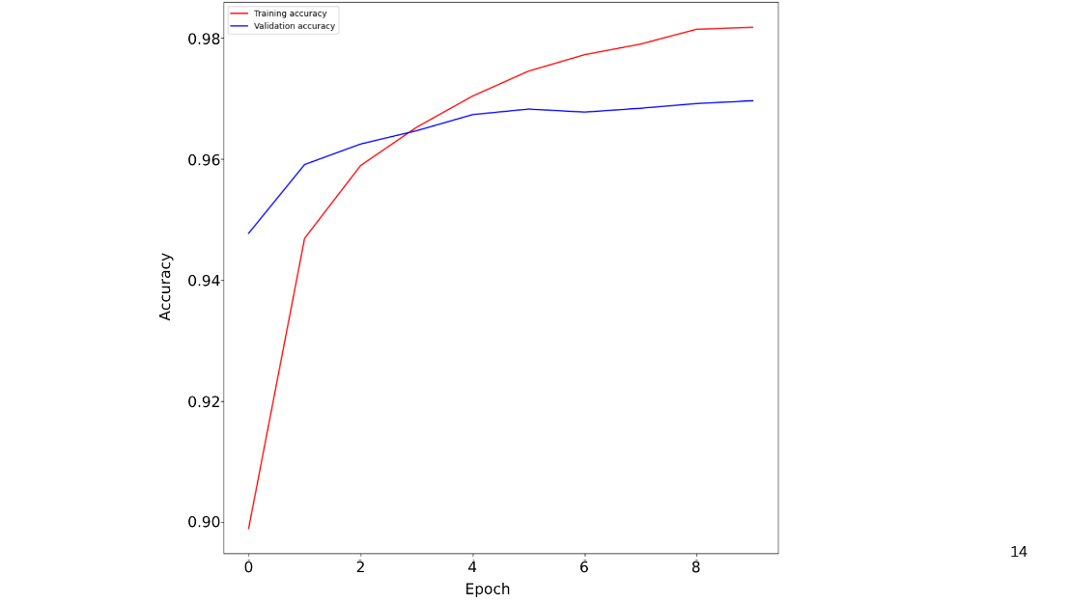Figure 5 Training and Validation Accuracy of InceptionV3

The upward trend in the accuracy curves of the InceptionV3 architecture, as shown in Figure 5, demonstrated an improvement in both training and validation performances. Training accuracy increased from an initial 90% to above 98%, and validation accuracy saw an increase from 94% to 97%. The close tracking of these curves indicated strong generalization and minimal overfitting (less than 5% difference between training and testing accuracies). This conclusion was then further supported by the smooth decline in both training and validation loss, as observed in Figure 6. Similarly, as seen in Figure 8, the accuracy curves of MobileNetV2 revealed a steady increase in training and validation performance from approximately 0.88 to 0.97 and 0.90 to 0.96, respectively. Figure 9 show that the training loss decreased consistently, the validation loss showed mild fluctuations after epoch 4, suggesting early signs of overfitting. The model achieved strong and robust performance on the test set. The overall close trajectory of both curves indicated the model still learnt effectively.
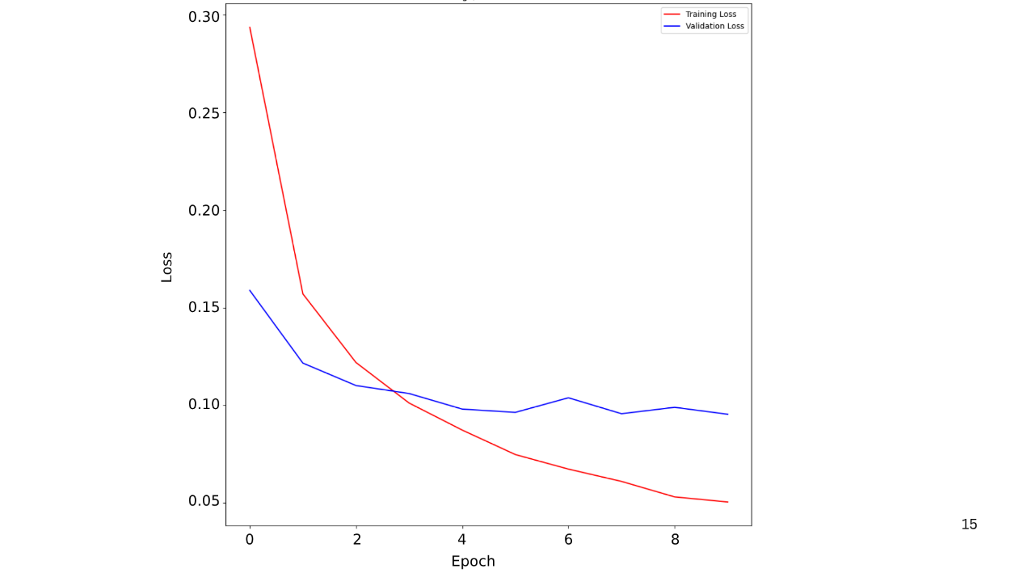Figure 6 Training and Validation Loss of InceptionV3

The narrow difference between these curves suggested strong generalization, avoiding overfitting. To evaluate class-wise performance, a classification report, as mentioned in Table 1, was generated.
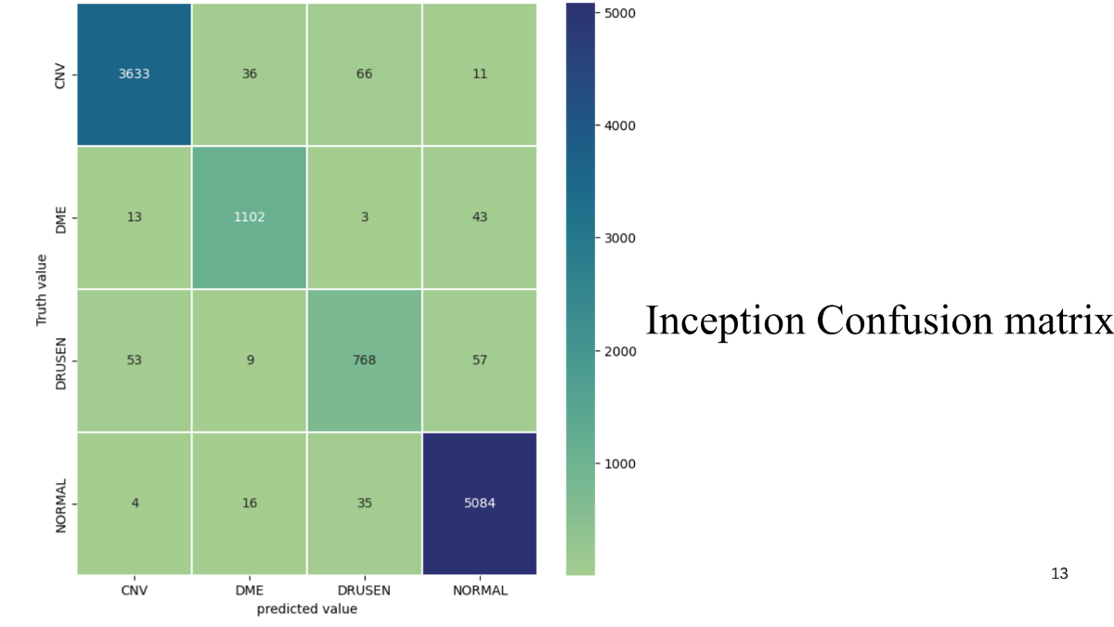Figure 7 Multi-Class Confusion Matrix by InceptionV3

CNV has excellent precision, recall and F1-score across both models, indicating reliable classification. DRUSEN shows high precision but low recall, suggesting that both the models correctly identified DRUSEN when predicted, but missed some actual cases. On the other hand, DME has higher precision, recall and F1-score for InceptionV3. Figures 7 and 10 portray the multi-class confusion matrices for InceptionV3 and MobileNetV2, respectively. Both models hold high accuracy with strong diagonals. InceptionV3 demonstrated superior performance, particularly for CNV and NORMAL classes, with minimal misclassifications. .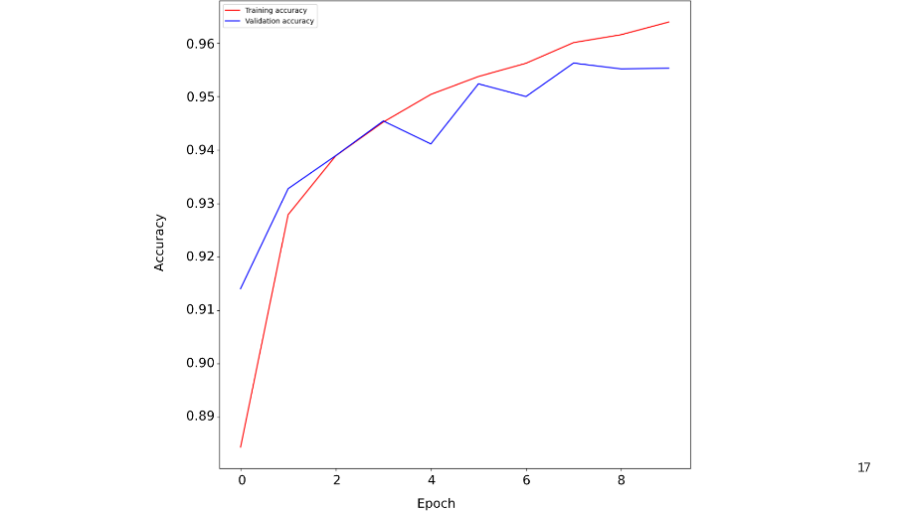
Figure 8 Training and Validation Accuracy of MobileNetV2

Class-wise accuracies were high for CNV (97%), DME (94.9%), and NORMAL (98.9%) but DRUSEN (86.6%) was more challenging to classify
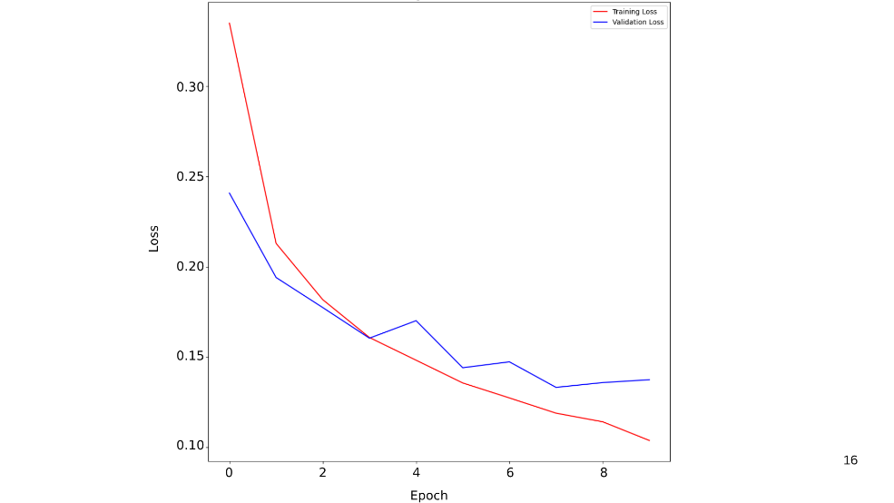Figure 9 Training and Validation Loss of MobileNetV2
MobileNetV2 also performed well but showed a slight reduction in discriminative accuracy. This is especially seen for DRUSEN, which exhibited overlap with CNV and NORMAL which correlates with its low F1-score. For MobileNetV2, the class-wise accuracies rank similarly, with high CNV (92.9%), DME (94.1%), and NORMAL (99%) accuracy, with lower DRUSEN accuracy (82.2%). These findings suggest that while MobileNetV2 offers computational efficiency, the deeper InceptionV3 architecture provides enhanced feature extraction and more robust class separation, particularly for visually similar retinal pathologies.

Table 1. Classification Reports for InceptionV3 & MobileNetV2
 | Precision |  | Recall |  | F1-score |  | Support
CLASS | IV3 | MV2 | IV3 | MV2 | IV3 | MV2 | IV3, MV2
0 | 0.98 | 0.98 | 0.97 | 0.93 | 0.98 | 0.96 | 3746
1 | 0.95 | 0.90 | 0.95 | 0.94 | 0.95 | 0.92 | 1161
2 | 0.88 | 0.79 | 0.87 | 0.82 | 0.87 | 0.81 | 887
3 | 0.98 | 0.97 | 0.99 | 0.99 | 0.98 | 0.98 | 5139
The results suggest that further improvement is possible, particularly in the case of drusen classification which does poorly. Future works can achieve so by applying feature enhancement techniques, focal loss functions, or different class-balancing strategies.
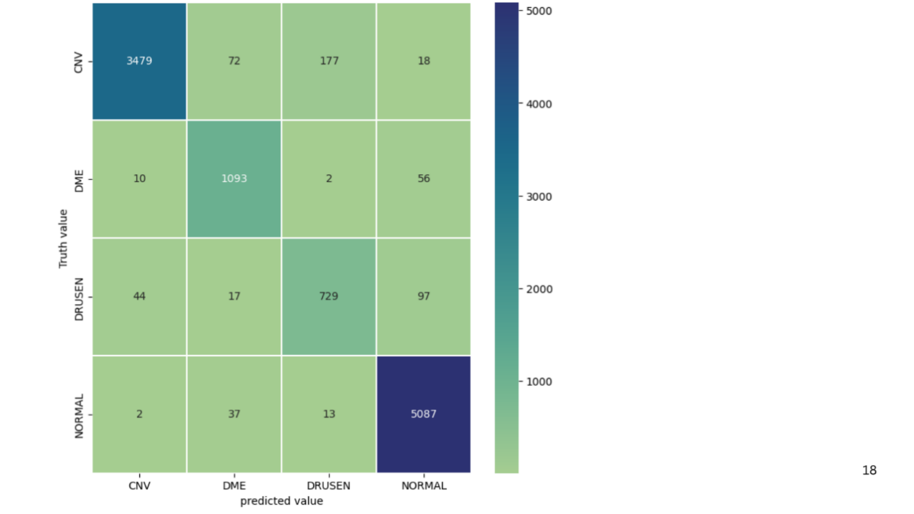Figure 10 Multi-Class Confusion Matrix by MobileNetV2
IV. Conclusion
In this research, we used InceptionV3 and MobileNetV2 architectures and performed full end-to-end fine-tuning to create deep learning models for the computerized diagnosis of retinal diseases. Class-weighting and data augmentation techniques were used during training to address the issue of class imbalance. The models achieved high accuracy of 96.83% and 95.05% respectively. Accuracy for CNV and NORMAL were high, while DRUSEN was a more difficult image class due to similar structural features. Our key contributions were exploratory data analysis, class balancing methods and a transparent evaluation pipeline that reported class-wise metrics. Our study demonstrates the feasibility of applying a deep learning approach in the field of ophthalmology while highlighting the need for evaluation, bias-informed decisions, and conscious design to produce clinically reliable medical imaging applications. The basis of this study also considers the practical constraints from imbalanced real-world datasets and deployment in resource-constrained contexts.

Acknowledgement
We gratefully acknowledge the staff and authorities of Manipal Institute of Technology, Manipal Academy of Higher Education (MAHE), especially the Department of Biomedical Engineering for their cooperation and their support in this research.
References
- Genetics and Genomics of Eye Disease. (2020). Age-related macular degeneration. pp. 155–180.
- Spalton, D. J., Hitchings, R. A., & Hunter, P. (2013). Atlas of Clinical Ophthalmology E-Book. Elsevier Health Sciences.
- Esfahani, R. P., et al. (2023). Deep learning classification of drusen, choroidal neovascularization, and diabetic macular edema in optical coherence tomography (OCT) images. Cureus.
- Varma, R., et al. (2014). Prevalence of and risk factors for diabetic macular edema in the United States. JAMA Ophthalmol., 132(11), 1334–1340.
- Aumann, S., Donner, S., Fischer, J., & Müller, F. (2019). Optical coherence tomography (OCT): Principle and technical realization. In High Resolution Imaging in Microscopy and Ophthalmology (pp. 59–85).
- Akpinar, M. H., et al. (2024). Artificial intelligence in retinal screening using OCT images: A review of the last decade (2013–2023). Comput. Meth. Prog. Biomed., 254, 108253.
- Jain, L., Murthy, H. S., Patel, C., & Bansal, D. (2018). Retinal eye disease detection using deep learning. In 14th Int. Conf. Inf. Process. (ICINPRO) (pp. 1–6).
- Rajagopalan, N., V. N., Josephraj, A. N., & S. E. (2021). Diagnosis of retinal disorders from optical coherence tomography images using CNN. PLoS One, 16(7), e0254180.
- Viedma, I. A., Alonso-Caneiro, D., Read, S. A., & Collins, M. J. (2022). Deep learning in retinal optical coherence tomography (OCT): A comprehensive survey. Neurocomputing, 507, 247–264.
- Özdaş, M. B., Uysal, F., & Hardalaç, F. (2023). Classification of retinal diseases in optical coherence tomography images using artificial intelligence and firefly algorithm. Diagnostics, 13(3), 433.
- Baba, S., Kumari, P., & Saxena, P. (2024). Retinal disease classification using custom CNN model from OCT images. Procedia Comput. Sci., 235, 3142–3152.
- Leandro, I., et al. (2023). OCT-based deep-learning models for the identification of retinal key signs. Sci. Rep., 13(1), 14628.
- Weiss, K., Khoshgoftaar, T. M., & Wang, D. (2016). A survey of transfer learning. J. Big Data, 3(1).
- Kermany, D. S., et al. (2018). Identifying medical diagnoses and treatable diseases by image-based deep learning. Cell, 172(5), 1122–1131.e9.
- Alkhawaldeh, I. M., Albalkhi, I., & Naswhan, A. J. (2023). Challenges and limitations of synthetic minority oversampling techniques in machine learning. World J. Methodol., 13(5), 373–373.

